An Introduction to TCP/IP Programming with Sockets

Phil Pfeiffer

ETSU Dept. Of Computer Science

Last updated April 2020

Introduction: TCP/IP, TCP/IP Communications, and Sockets
The world’s largest network of interconnected computers is the Internet. The Internet, which began as a federal research project, has grown from a seven-computer network into world-wide network that, according to Mayaan, linked roughly 31 billion devices in 2020 [Mayaan20].
Work on Internet protocols began in the mid-1970’s, with the network architecture and the protocols assuming their current form by 1979 [Comer91, p. 6]. The suite of protocols that define the Internet, which was never officially named, is commonly referred to as the TCP/IP Protocol Suite or TCP/IP for short. This name honors the Internet’s two keystone protocols.
- The first, the Internet Protocol (IP), routes chunks of data known variously as IP datagrams or packets through a network of connected computers. IP guarantees that packets that aren’t mangled or discarded in transit will be delivered to the proper address. IP, however, does not guarantee that messages will arrive safely, or at all.
- The second, the Transport Control Protocol (TCP), uses IP to create a reliable, connection-based service for exchanging information. Figure 1 depicts sample TCP-IP connections between two host computers. A connection is a two-way communications path that carries content between two logical network drop-off points. These drop-off points, known as sockets, consist of a host computer C, together with a local drop-off for information on host C known as a port.
TCP uses numbers to identify protocol objects. Ports are assigned numbers in the range 1 ... 65,535. Hosts are assigned four-byte addresses that range from 1.1.1.1 to 223.255.255.255. A socket S is named by naming S’s host and associated port. Finally, a connection is named by naming the connection’s endpoints.
Intuitively, TCP’s mechanism for inter-computer communications is analogous to phone company mechanisms for managing phone service. In this analogy, a computer corresponds to a central phone company office; a computer’s IP address to an area code; a port to a point of termination at the central office; a port number to a local phone number; a socket to a pairing of an area code with a local phone number; and a connection to a link between two ((area code), (local phone company)) pairs.
Other key parallels between network management and phone company operations illustrate TCP/IP's approach to managing network services. A name that allows a user to access a network entity is called a service access points (SAP). Phone companies and mainstream operating systems treat service access points as resources that are acquired on demand, managed by the acquirer while in use, and returned to the pool of resources when no longer needed. A more careful explanation of these parallels now follows.

Computer 4.5.6.7
Computer 8.9.10.11
Figure 1. The TCP mechanism for end-to-end communications.
For clarity, IP addresses are italicized, and port numbers are rendered in a standard font
The Network
port 33
port 10
port 25
port 110
TCP connection ((4.5.6.7, 215), (8.9.10.11, 25))
TCP connection ((4.5.6.7, 40), (8.9.10.11, 110))
TCP connection ((4.5.6.7, 33), (8.9.10.11, 10))
port 215
port 40
sockets (8.9.10.11, 10)
(8.9.10.11, 25)
(8.9.10.11, 110)
sockets (4.5.6.7, 33)
(4.5.6.7, 215)
(4.5.6.7, 40)
Telco approach to managing SAPs. Entities that want to receive calls first obtain a phone number from the company. Phone numbers are neither shared nor policed: a number, once assigned, is controlled by its owner, who chooses when to listen for calls and what to say. The primary responsibility for terminating phone service rests on those who hold the phone numbers. The phone company, as a rule, will not revoke a living customer’s service, save for nonpayment.
Mainstream OS approach to managing SAPs. A task ServerTask that wishes to serve the needs of other network tasks via TCP must typically use a protocol like the one below:
- Assume, for this example, that ServerTask runs on a computer named ServerHost. ServerTask must first ask ServerHost’s operating system for permission to use one of ServerHost’s ports. If permission is granted, say, to use port Portnum, then ServerTask now has exclusive access to socket (ServerHost, Portnum).
- ServerTask declares its intent to accept connections on socket (ServerHost, Portnum).
- ServerTask listens for connections on its socket. This listening may be accomplished in one of three ways:
- ServerTask can block; that is, ServerTask can issue a system call that suspends ServerTask’s execution until a “call” comes in on (ServerHost, Portnum). Intuitively, this equates to watching a phone, and doing nothing until the phone rings.
- ServerTask can issue a nonblocking system call that asks the system to set a predetermined flag when a “call” comes in on (ServerHost, Portnum). ServerTask then resumes processing, checking the flag periodically to determine if a “call” has arrived. Intuitively, this equates to periodically checking a phone for messages.
- ServerTask can issue a nonblocking system call that asks the system to interrupt ServerTask at a prearranged statement when a “call” comes in on (ServerHost, Portnum). Intuitively, this equates to doing other work while waiting for a ring.
It is ServerTask’s responsibility to relinquish Portnum when processing is finished. If ServerTask fails to notify the operating system that wishes to release Portnum, then Portnum will be not reclaimed for reuse until ServerTask exits.

Socket APIs, BSD Sockets, and Winsock
An Application Program Interface (API) is a set of functions that define a service's look and feel. One example of a common API is the C programming language’s file i/o package, which includes routines like fopen( ), fread( ), fwrite( ), and fclose( ). These routines serve as an interface between users' programs and the underlying operating system’s file system. A second API for file i/o is the C++ fstream object, which provides member functions like open( ), read( ), write( ), and close( ). In theory, any service can have an unlimited number of APIs. In practice, a service typically has one de facto standard API per operating system/language pairing.
A socket API is a set of routines that allow programs to use sockets to exchange messages. For years, the de facto standard for socket APIs was BSD Sockets, an API developed by the Computer Systems Research Group at the University of California-Berkeley [Stevens92]. This package was later adapted for use in MS Windows, under the name Winsock. The BSD Socket and the Winsock APIs define system calls that do the following:
- manage sockets—that is, instantiate sockets, and pair sockets with protocols and port numbers;
- manage connections—that is, open and close connections, exchange data along connections, and return status information; and
- identify resources in the network environment.
The Winsock API omits a few of the routines in the BSD API and includes other Windows 3.x-specific routines that support the use of concurrent socket calls. Most of what is said below, however, applies to BSD Sockets as well as Winsock.

Socket API Functions—A Synopsis
The following section summarizes two basic BSD/Winsock models for two-way socket communication. For more on socket programming, see texts like [Comer91, Comer91a, Comer93, Stevens92], which describe socket programming in Unix, and [Quinn96, Sinha96], which describe socket programming under Windows.

The Socket Model for Network Programming
The socket model for networked communications, an asymmetric model, postulates two broad classes of programs:
- Programs that initiate communications, often referred to as client processes, or clients; and
- Programs that respond to requests for communication, often referred to as server processes, or servers.
A typical client-server communication can be broken into an initialization phase, a dialogue phase, and a termination phase.
Initialization phase. In a communication's initial phase a client and server first instantiate a socket for communications, using socket():
socket( ) — initialize a socket descriptor. This includes specifying the protocol that the client and server will use to communicate over a socket. For example, a call to socket( ) that sets up TCP-based communications specifies AF_INET—a constant that designates the TCP/IP protocol suite—as its first argument.
The server and client then associate SAPs with the sockets and prepare the sockets for exchanging messages. The procedure for completing the initialization phase depends on the protocol in use and the type of the endpoint being initialized.
Initialization phase, connection-oriented operation. In the connection-oriented TCP protocol, servers acquire SAPs by using bind() to associate a port number with a socket:
bind( ) —accepts a port number as a parameter. Fails if the specified port cannot be associated with the specified socket (e.g., port number has already been taken).
The server then completes the initialization step by calling listen() and accept():
listen( ) — prepare a socket to receive connections. The server process uses listen( ) to specify the number of simultaneous requests for connections that the server will accept.
accept( ) — accept a connection.
Client programs use one call to acquire a service access point and contact the server:
connect( ) — connect to a server that has first called accept( ). connect( ) only specifies the host and port connected to—the socket on the server. The socket API automatically selects the client port from an unused client port.
The initial phase of the connection-oriented mode of operation ends when the server accepts the client’s request to connect.
Initialization phase, connectionless operation. The TCP/IP suite supports a second protocol, UDP, which implements a U.S. Postal Service-like communications service, in that no connections are maintained, and message delivery is not guaranteed.
In UDP, the client and server use bind() to acquire SAPs. Since UDP is connectionless, no further initialization is needed.
Dialogue phase. In a communication's second, dialogue phase, a client and server exchange content. The primitives used depend on whether connection-oriented or connectionless communications are in use.
Dialogue phase, connection-oriented operation. In TCP, client and server use send( ) and recv( ) to exchange content:
send( ) — send a block of data through a TCP socket, through a predetermined connection.
recv( ) — receive a block of data from a TCP socket, through a predetermined connection.
Dialogue phase, connectionless operation. In UDP, client and server use sendto( ) and recvfrom( ) to exchange content:
sendto( ) — send a block of data through a UDP socket, specifying the receiver’s IP address and port number
recvfrom( ) — receive a block of data from a UDP socket, capturing the sender’s IP address and port number.
TCP's use of a connection eliminates the need for the sender data supported by sendto( ) and recvfrom( ).
The BSD Sockets and Winsock APIs also allow a UDP sender “connect()” to a remote host prior to sending transmissions. The UDP connect() primitive is a convenience that establishes a default destination for outgoing messages—thereby allowing a sender to used send( ), rather than sendto( ), to convey messages to the default destination.
The dialogue phase of a communication ends when one or the other party stops communicating.
Termination phase. In a communication's final phase, a client and server close their sockets, using one of two primitives:
close( ) — close a socket (BSD sockets only).
closesocket( ) — close a socket (Winsock only).
In TCP, closing a socket immediately disrupts the client-server connection, and causes all data currently en route between the endpoints to be discarded. A more graceful strategy for closing a connection uses a primitive known as shutdown( ) to alert the other endpoint to the impending close. For more on shutdown( ), see the aforementioned texts on socket programming.
Figures 2 and 3 summarize the basic steps in TCP-based and UDP-based communications.
The socket APIs support additional feature sets for implementing various modes of client-server communication. One, support for concurrency, support inputs from multiple clients, in either of two ways:
- Servers can be configured to receive input from multiple clients, and to process input from one client at a time.
- Servers can be configured to receive input from multiple clients, and to process input from multiple clients concurrently. Concurrency may be achieved by spawning—i.e., “cloning”—the original server, or through the use of multithreaded servers. .
A variety of system calls and special options support concurrent operation, including select( ), the ioctl( ) nonblocking mode parameter, and the Winsock WSAasync family of calls. See the references for details.
A second, support for socket reuse, allows multiple tasks to share (i.e., bind( )) a common port. This feature, unfortunately, is less useful than it might have been, due to a lack of standards for traffic management. For example, Ultrix delivered a message to a reused port P to all sockets bound to port P, while NT 3.51 delivered the message to just the first socket that retrieved it.
A third, support for sockets as streams, allows a connected socket to be opened like a stream (i.e., a file) and manipulated using standard routines for file I/O. BSD and—I believe Winsock 2.2—support the use of sockets as streams. Winsock 1.1 did not, which led to the distinction between close() and closesocket().

Routines That Manipulate Connection-Related Status Information
The socket APIs provide the following routines for manipulating status information on connections:
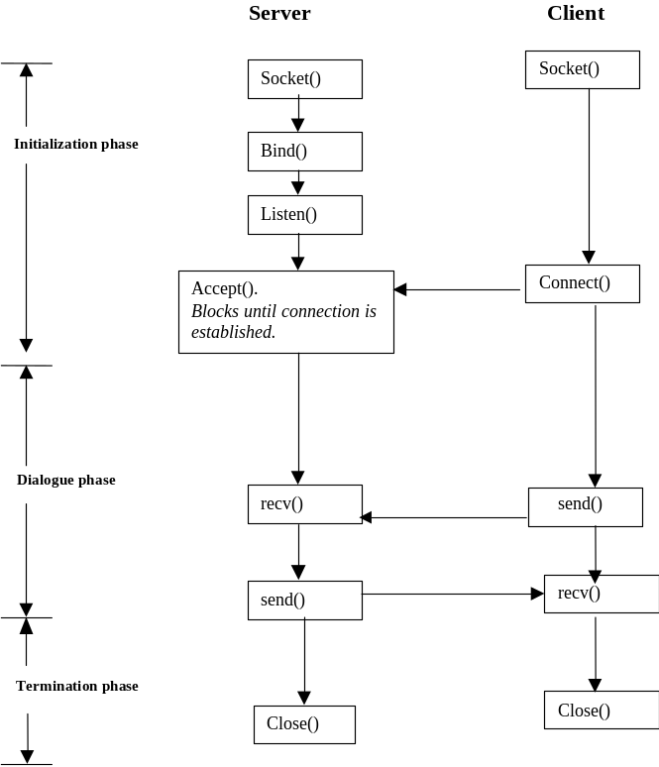
Fig. 2 (S.Koritala). Socket system calls for TCP. Windows platforms use closesocket(), rather than close( ).
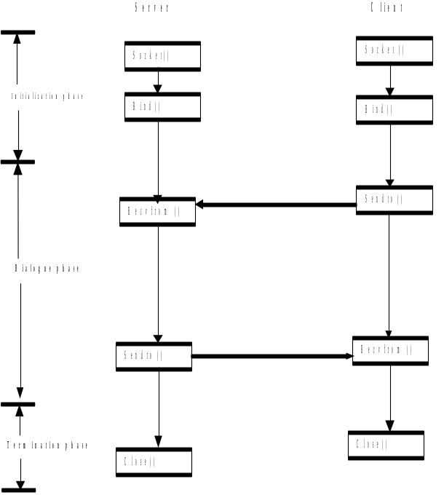

Fig. 3 (S.Koritala). Socket system calls for UDP. Windows platforms use closesocket( ) rather than close( ).
- getsockopt( ), setsockopt( ) — get and set attributes of socket connections. These attributes are system- and protocol dependent, and include concerns like buffer size, response timeouts, and number of retries to attempt following errors in transmission.
- getpeername( ) — returns the IP address and port number of the socket on the remote end of the connection.
- getsockname( ) — returns the IP address and port number of the socket on the local end of the connection.

Routines That Identify Resources in Network Environments
In order to contact a server process at another site, a client process must have some way of discovering the identity of that server process's socket. This problem of resource discovery is often handled by “punting”: the client process is expected to know the name of the computer that hosts the server process, as well as the port on which that server is listening for connections.
The TCP/IP protocol suite, however, contains some services for discovering facts about the network environment. The following are its basic routines for network resource discovery:
- gethostname( ) — allow a process to obtain the name of the host on which it is currently running.
A typical hostname is a hierarchically organized series of identifiers that identify the domains of authority within which the host resides. A hostname like www-cs.etsu.edu, for example, identifies its host as a computer at an educational institution (edu) named East Tennessee State University (etsu). Similarly, herve.cs.wisc.edu is a computer at an educational institution named the University of Wisconsin-Madison (wisc) that belongs to Wisconsin’s computer science department (cs). Translations between host names and IP addresses are managed using a network-wide computer naming system known as the domain name system (DNS).
- gethostbyaddr() — return data from the local domain’s DNS on the specified host. Accepts an IP address as its argument.
- gethostbyname() — return data from the local domain’s DNS on the specified host. Accepts a domain name as its argument.
The following two auxiliary routines are useful for converting between ASCII and binary representations of IP addresses
- inet_ntoa( ) — converts a 32-bit integer representing an IP address to a string.
- inet_addr( ) — converts a string representing an IP address to a 32-bit integer.
These final two routines, inet_ntoa( ) and inet_addr( ), are two of the more commonly used routines in the Winsock API. inet_ntoa( ) allows a programmer to recover an address returned by gethostbyname( ), and convert that address to ASCII, for output. inet_addr( ), on the other hand, allows a programmer to turn a string like “1.2.3.4” into an address that can be used by gethostbyaddr( ).

Byte Ordering for Multibyte Data Items
The sockets APIs support four procedures for transmitting 2- and 4-byte integers over networks. Two, htons() and htonl(), translate short (2-byte) and long (4-byte) integers to a network-independent format, respectively. The remaining two, ntohs() and ntohl(), translate 2- and 4-byte integers from a network-independent format to the current host's format. These translations are critical for ensuring that data is sent correctly between hosts with different formats: e.g., from little- to big-endian hosts.

Rewrapping the Socket API Functions
A variety of newer languages like Java and Visual Basic simplify the sockets API by hiding some system calls from the user, and combining others. The call to socket( ), for example, is typically “hidden” in a class’s or a component’s definition, along with calls to routines like bind( ) and listen( ). Underneath the wrappers, however, these languages are still using the pattern of calls shown in Figures 2 and 3 to support inter-task sessions.

References
[Comer91] Douglas Comer, Internetworking With TCP/IP, Vol. I, Prentice-Hall, 1991
[Comer91a] Douglas Comer and David Stevens, Internetworking With TCP/IP, Vol. II, Prentice-Hall, 1991
[Comer93] Douglas Comer and David Stevens, Internetworking With TCP/IP, Vol. III, Prentice-Hall, 1993
[Mayaan20] Gilaad Mayan, "The IoT Rundown For 2020: Stats, Risks, and Solutions", https://securitytoday.com/Articles/2020/01/13/The-IoT-Rundown-for-2020.aspx?Page=2; last accessed 12 April 2020
[Quinn96] Bob Quinn and David Shute, Windows Sockets Network Programming, Addison-Wesley, 1996
[Sinha96] Alok Sinha, Network Programming in Windows NT, Addison-Wesley, 1996
[Star] Stardust Technologies, Inc., “Windows Sockets 1.1 Specification - Socket Library Reference”, http://www.winsock.com/wsresource/winsock1/ws_c.html
[Stevens90] Richard Stevens, UNIX Network Programming, Prentice-Hall, 1990
[Stevens92] Richard Stevens, Advanced Programming in the UNIX Environment, Addison-Wesley, 1992

Addresses between 224.0.0.0 and 239.255.255.255 support a service known as multicast. Addresses between 0.0.0.0 and 0.255.255.255, as well as addresses 240.0.0.0 and 255.255.255.255, are reserved for other uses. 255.255.255.255, for example, denotes “this network”.
inet_ntoa( ) and inet_addr( ) are also two of the logically sleaziest routines in the socket APIs. An IP address in IPv4 is a series of four distinct 8-bit values. The standard structure for holding an IPv4 address is the in_addr (think: Internet address). This in_addr structure is defined as follows: struct { struct { struct { s_b1, s_b2, s_b3, s_b4: unsigned char; } S_un_b; } S_un; } in_addr; For “convenience” the developers of the inet_addr( ) API defined inet_addr( ) as a routine that produced a 32-bit-long integer, rather than a struct in_addr. Similarly, standard texts on socket manipulation routinely show code that invokes inet_ntoa( ) on data that has been cast as a pointer to an object of type struct in_addr. How exactly this cast is done differs, depending on whether BSD Sockets (struct in_addr *) or Winsock (LPIN_ADDR) is in use.

